Some basic points before starting Linear Regression.
Equation of the straight line
y = m x + c | Or
y = β₀ + β₁ X₁ | Or
h_{θ}(x) = θ₀ + θ₁ X₁ | Or

Intercept θ₀ or β₀ OR c :
Where the best-fit line meets the Y axis).

Slope or Coefficient θ₁ or β₁ or m :
If there is a unit movement on the x-axis then, what the movement on the y-axis is called slope.

Predicted point (h_{θ}(x) or y) : is the predicted point.

Actual Point X₁ or x :
Is the actual point.
Error/Residual: The difference between a real point and a projected point is called Error/Residual.

To find the best-fit line we should be changing the intercept c and Coefficient m Values.

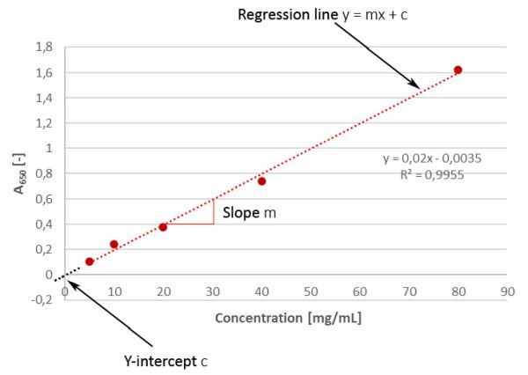

Linear Regression
Using a straight line, a simple linear regression model estimates the relationship between one independent variable and one dependent variable. Both variables should be quantitative.
Imagine you're trying to predict someone's weight based on their height. In linear regression, you'd look at a bunch of people's heights and weights and draw a line that best fits the data points. This line helps you make predictions about weight for different heights.
The "linear" part means the line you draw is straight, and "regression" is about finding the best-fitting line that minimizes the differences between the actual data points and the predicted points on the line. This way, you can estimate one variable (like weight) based on another variable (like height) using a simple equation, which makes it easier to understand and predict relationships between different factors.
Linear regression is to find the minimum distance between the variables and the straight fit line.
The aim of Simple Linear regression is to find the best-fit line.
Step by Step Explanation of how the best fit straight line is created.
Step 1: Guess a Line:
Start with a guess for a straight line that you think could fit the data. This line is represented by an equation: y = mx + c, where 'm' is the slope and 'c' is the y-intercept.
Step 2: Calculate Errors (Residuals)
For each data point, calculate the vertical distance between the actual y-value (data point) and the predicted y-value. These distances are your errors or residuals.
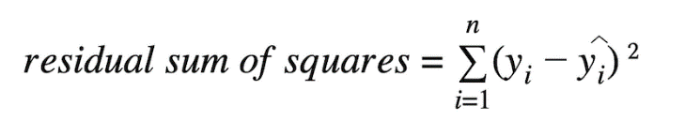
Step 3: Compute the Cost: Calculate the cost function by adding up the squared errors for all data points. The formula might look like the sum of (actual y - predicted y)^2 for each data point. This gives you a single value that indicates how well your guessed line fits the data.
Step 4: Adjust the Line: The goal is to minimize the cost function. To do this, you adjust the slope 'm' and the y-intercept 'c' of your guessed line. You want to find the values of 'm' and 'c' that make the cost function as small as possible.
Step 5: Gradient Descent: If using gradient descent, you calculate how much to change 'm' and 'c' based on the slope of the cost function. This helps you move closer to the minimum cost point with each iteration.
Cost functions / Metrics for Regression.
A cost function, also known as a loss function or objective function, is a mathematical measure that evaluates the discrepancy(error) between predicted points and the true values or labels in the training data and serves as the basis for optimizing the model during training.
The objective is to minimize the Error by adjusting the model's parameters (intercept c and Coefficient m), enabling the model to make more accurate predictions and improve its overall performance on the given task.
Here we are going to study three types of cost functions as below which are used in linear regression:
- MSE (Meas Square Error)
- MAE (Mean Absolute Error)

Mean Squared Error (MSE): | Mean Absolute Error (MAE): | Root Mean Squared Error (RMSE):
MSE measures the average of the squared differences between predicted and actual values. | MAE measures the average of the absolute differences between predicted and actual values. | RMSE is the square root of the MSE and shares similar characteristics but is in the same units as the target variable.
It squares the errors, penalizing larger errors more heavily than smaller errors. | It does not square the errors, thus treating all errors equally regardless of size. | RMSE provides a measure of the average magnitude of errors, with the advantage of being in the original units of the target variable.
Because of squaring, MSE is sensitive to outliers. | MAE is less sensitive to outliers compared to MSE. | Like MSE, RMSE is also sensitive to outliers.
It's useful when you want to penalize larger errors more significantly or when you're interested in the variance of the errors. | It's useful when you want a metric that's more interpretable and less influenced by outliers. | It's useful when you want to interpret the average error magnitude in the original units of the target variable.
MSE is a convex function. It has a single, global minimum, which means that any local minimum is also the global minimum. | MAE is not convex, but it can be considered convex for practical purposes. It is piecewise linear with multiple linear segments. | RMSE also has a convex function. It has a single, global minimum, which means that any local minimum is also the global minimum.

Performance Metrix: Performance Metrix is used to know the accuracy of the model and they tell you if you're making progress or not. Here we will discuss two types of performance metrics.
- MSE (Meas Square Error)
- MAE (Mean Absolute Error)
- RMSE (Root Means Square Error)
- R Square
- Adjusted R Square

Mean Squared Error:
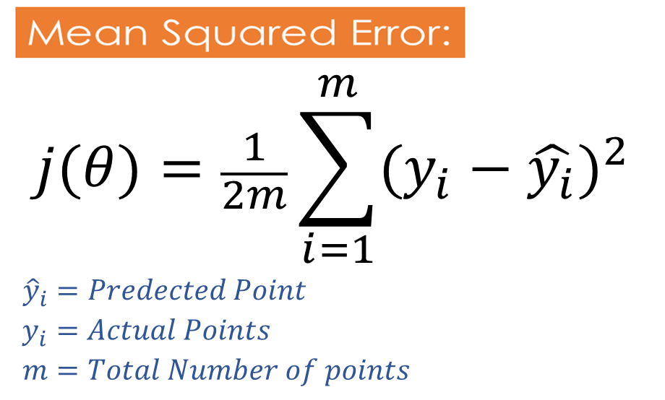
MSE works by calculating the squared differences between each predicted value and the corresponding actual value, summing them up, and then dividing them by the total number of data points.
By squaring the differences, negative and positive errors are both considered, and larger errors are penalized more heavily, giving more weight to larger deviations between predictions and actual values.
MSE is particularly popular due to its mathematical properties, including convexity, which makes it easier to optimize when training machine learning models.
However, it is sensitive to outliers and may not be an ideal metric in cases where the data is heavily skewed or contains heteroscedasticity (varying levels of error across the range of the target variable).
A lower value of MSE indicates that the model's predictions are closer to the actual values, and thus, a lower MSE is desirable as it signifies better model performance.

Advantages | Disadvantages
- This equation is differentiable (differentiable is required to calculate slope, to update the θ₀ and θ₁ )  - This equation creates a convex function.  - Since this function creates a convex function, it has one global minimum | - Since residuals are penalized by squaring it up, it is not robust to Outliers.  - No Unit of Measurement: MSE is expressed in the square of the units of the target variable, which can make it difficult to relate to the original data units.

Mean Absolute Error:
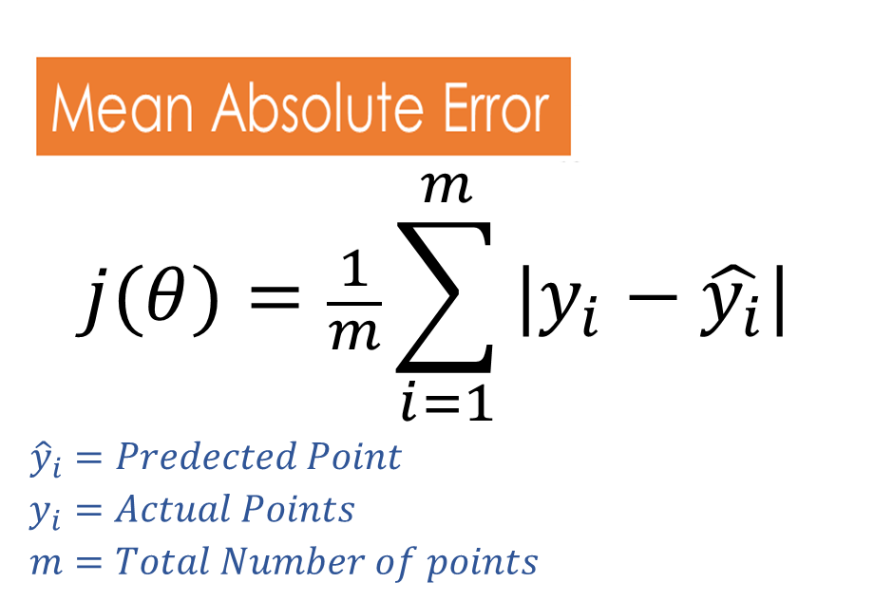
MAE works by taking the absolute difference between each predicted value and the corresponding actual value, summing them up, and then dividing by the total number of data points.
MAE does not square the differences between predicted and actual values. This means that MAE treats positive and negative errors equally and does not penalize larger errors more heavily.
MAE is particularly useful in scenarios where outliers may have a significant impact on the model's performance. Since it takes the absolute value of the errors, extreme deviations between predictions and actual values do not have an inflated effect on the overall MAE value.
This function uses the subgradient concept to calculate the derivative.
Advantages | Disadvantages
- Robust to outliers  - Remains in the same unit, since residuals are not penalized by squaring it. | - Conversion takes usually takes a lot of time since the same unit is used.  - Optimization is usually a complex task

Root Mean Squared Error
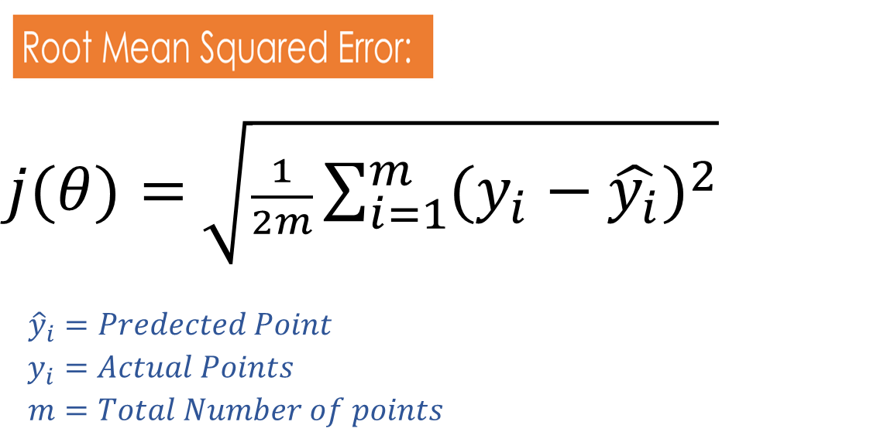
RMSE is similar to Mean Squared Error (MSE), but RMSE is taken as the square root of MSE to make the units of the error metric consistent with the original target variable. By taking the square root, RMSE is in the same unit as the target variable, making it more interpretable and easier to compare with the scale of the original data.
It penalizes larger errors more heavily, giving a higher weight to larger deviations between predictions and actual values.

Advantages | Disadvantages
- Sensitivity to Large Errors: RMSE gives higher weight to larger errors due to squaring the differences between predicted and actual values. This sensitivity makes it suitable for applications where large errors are more critical and need to be penalized appropriately.  - RMSE is widely used and easy to understand. The metric is expressed in the same units as the target variable, which makes it more interpretable and relatable to the problem domain. | - Since residuals are penalized by squaring it up, it is not robust to Outliers.

R Square
R-squared(r2 Square), also known as the coefficient of determination, is a performance metric used to evaluate the goodness of fit of a linear regression model. It provides an indication of how well the model explains the variation in the dependent variable based on the independent variables.
R-squared is a value between 0 and 1. A value of 0 indicates that the model does not explain any of the variability in the dependent variable, while a value of 1 indicates that the model perfectly explains all the variability.
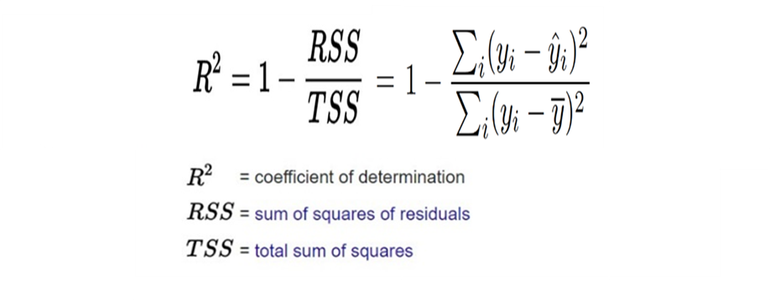

Adjusted R Square:
There may be instances where certain features within a model are not correlated with the output feature. Logically, these features should decrease the accuracy of the model, but in reality, they actually improve the accuracy. This can lead to an unclear understanding of the model's performance and can result in poor real-time performance if deployed. To avoid such scenarios, the "adjusted R squared" formula is used. This ensures that the accuracy of the model decreases when non-correlated features are added and these features are removed during the training phase.
Adjusted R-squared is a modified version of the R-squared (coefficient of determination) that takes into account the number of independent variables in the model. It is used to assess the goodness of fit of a regression model while penalizing the inclusion of unnecessary independent variables.

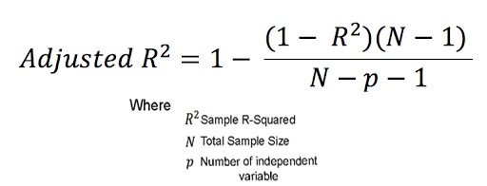

Overfilling and Underfitting (Bias and Variance):

Bias :
Accuracy of the training data is mentioned by Bias.
There are two types of Bias
- Low Bias :if Training Data has Very Good Accuracy then it is Low Bias.
- High Bias :If Training Data has Bad Accuracy then.
Variance:
Accuracy of the test data is mentioned by Variance.
There are two types of Variance
- Low Variance: if Testing Data Very Good Accuracy.
- High Variance: if Testing Data Bad or Good Accuracy.

Overfitting:
If training Data has Very Good Accuracy(Low Bias) while Testing Data has Bad Accuracy (High Variance) then this condition is called overfitting. To solve such a problem need to perform hyperparameter tuning.
Underfitting :
If training Data has Very Bad Accuracy(High Bias), while Testing Data has Bad (High Variance) or Good Accuracy (Low Variance) then this condition is called Underfitting.

Lasso Regression: (L1 Regularization):
Lasso adds a penalty term. This penalty term is the sum of the absolute values of the coefficients multiplied by a constant often denoted as lambda or alpha. The equation of the same is given below.

Equation after adding the Lasso(L1)

The main aim of the Lasso is to reduce the number of features it is used to do the feature selection.
Some coefficients(slope) are driven to exactly zero, performing feature selection and keeping only the most important features.
Useful for feature selection when you suspect some features are irrelevant or redundant, and you want a more interpretable model.
L1 regularization encourages sparsity in the model, meaning that it drives some coefficients(Slopes) to exactly zero. This results in a simpler model with fewer features, as some features are effectively ignored in the final model. L1 regularization is particularly useful for feature selection, as it automatically identifies and selects the most important features in high-dimensional datasets.
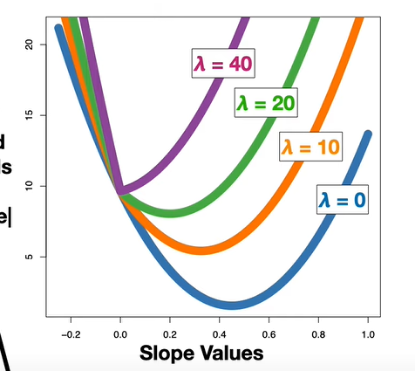

Ridge Regression:(L2 Regularization)
Ridge is used to deal with Overfitting and multicollinearity
As It helps to reduces the overfitting and Useful for dealing with multicollinearity when you want to reduce the impact of all features without eliminating them entirely.
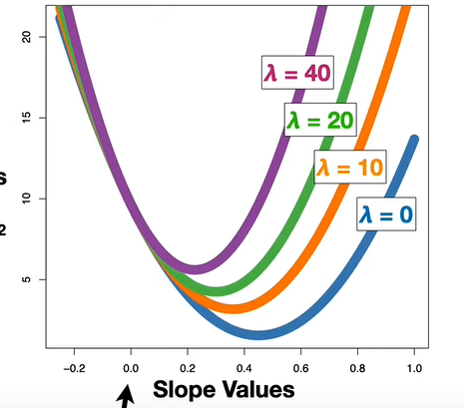
Coefficients are shrunk towards zero but rarely become exactly zero, allowing all features to remain in the model.
In ridge regression, the regularized loss function is defined by adding a penalty term based on the squared values of the model's coefficients (weights). The penalty term is controlled by a hyperparameter λ (lambda). The formula for the regularized loss function in ridge regression is as follows
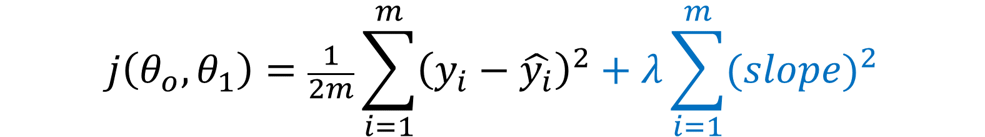
Equation after adding the Ridge(L2)

L2 regularization discourages large parameter values and promotes smoother parameter estimates. It does not lead to sparse solutions like L1 regularization, as it does not drive coefficients to precisely zero. Instead, it shrinks the values of the coefficients towards zero, but they remain non-zero.
Ridge Regression is effective at mitigating multicollinearity (high correlation among independent variables) and stabilizing the model.

ElasticNet Regression:
Elastic Net regression is an extension of linear regression that combines both L1 (lasso) and L2 (ridge) regularization techniques.
It aims to overcome some limitations of ridge regression and lasso regression by providing a balance between overfitting multicollinearity and feature selection.
Elastic Net strikes a balance between the two techniques and is useful for high-dimensional datasets with correlated features, offering flexibility in handling multicollinearity while performing feature selection.
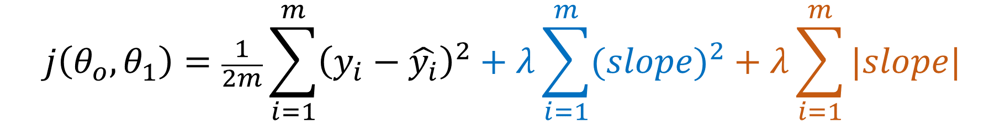

Gradient descent:
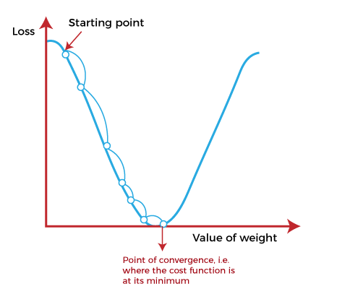
Convergence Algorythem:
θ_{j}= | θ_{j} - α | ∂J(θ_{j})
 |  | ∂θ_{j}

For –ve Slope
θ_{j =} θ_{j –} α (-ve)
For +ve Slope
θ_{j =} θ_{j –} α (+ve)

Assumptions of Linear Regression:
Linear regression makes several key assumptions about the relationship between the independent variable(s) (features) and the dependent variable (target). These assumptions are essential for the model to be reliable and the results to be interpreted correctly. Here are the main assumptions of linear regression:
Linearity: The relationship between the independent variables and the dependent variable is assumed to be linear. This means that changes in the dependent variable are proportional to changes in the independent variables, according to a straight line.
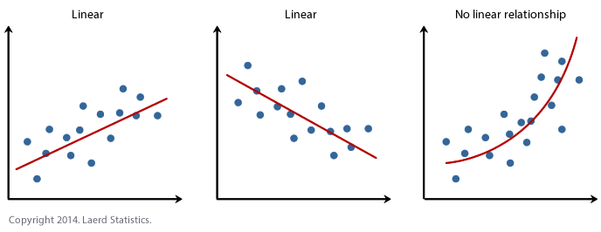
2. No Multicollinearity: There should be no exact linear relationship between the independent variables (multicollinearity). High correlation among independent variables can lead to instability in the estimation of the coefficients.
3. Normally distribution of Errors: when we plot the error the plot should be normally distributed.
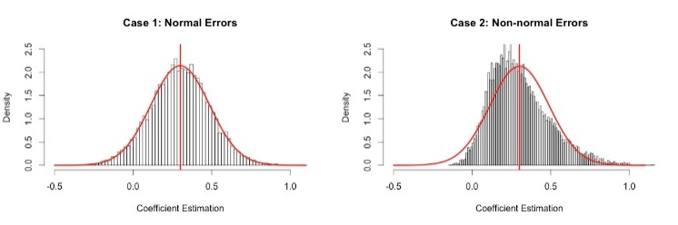
4. Homoscedasticity (Constant Variance): The variance of the residuals should be constant across all levels of the independent variables. In other words, the spread of the residuals should be consistent as you move along the range of predicted values.
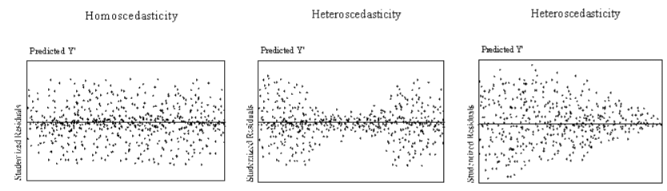

5. No Autocorrelation: The residuals should not be correlated with each other. Autocorrelation occurs when the residuals from a time series regression are correlated with each other at different lags.
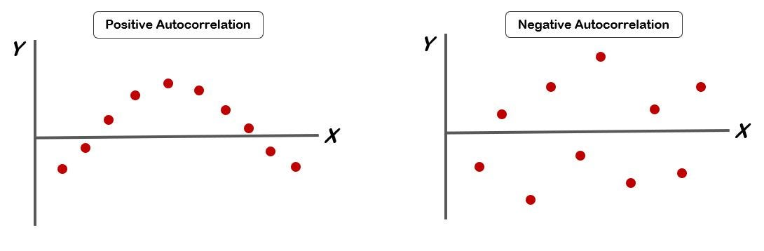

These assumptions are crucial for interpreting the results of a linear regression model correctly and for ensuring the reliability of the conclusions drawn from the analysis. Violations of these assumptions can lead to biased estimates, incorrect inferences, and unreliable predictions. Therefore, it's essential to assess these assumptions when applying linear regression in practice.

